Warning – Traction Control/AdvanceTrac Always On with TC/ESC Switch NOT Hard Wired to IPC – CGEA1.3

Functional Description

This STSS is used for applications where a hard TC/ESC Off switch is used (instead of settings menu selection) and that switch is NOT hard wired to IPC (hard wired to another module such as ECP or ABS for example). When this STSS is used, Warning – Traction Control Always On with TC-ESC Switch Hard Wired to IPC STSS and TC-ESC-RSC Switch STSS are NOT used.

The purpose of the Traction Control Always On Warning is to inform the MyKey Restricted User that the MyKey Administrator has configured the Traction Control System to always be on. This information is displayed in the Message Center if the MyKey Restricted User attempts to disable the Traction Control/ESC System via the Traction Control/ Electronic Control Stability switch. (i.e. this warning is displayed on the Message Center display whenever the TC_Always_On_MC_Status_Flag = Active).

The Traction Control Always On Warning correlates the BrkMdeInhbt_B_RqDsply signal and the Operational _Mode to determine when to display the Traction Control Always On Warning.

Interfaces

Interface Context Diagram (I/O Block Diagram)

Figure 1 Warning – MyKey Traction Control/AdvanceTrac Always On

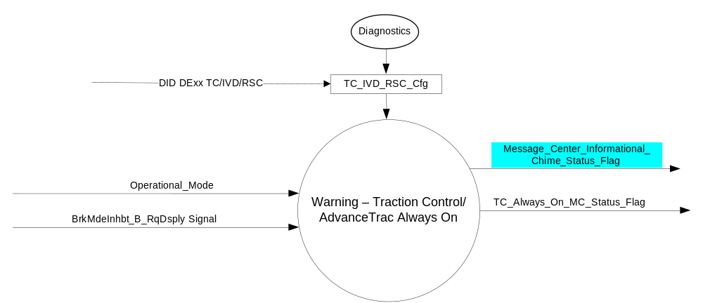

Inputs
      - INTERNAL:
    - Operational_Mode
MUX message on the CAN Bus from the ABS

- BrkMdeInhbt_B_RqDsply Signal
Signal Name | Size  (bits) | Detail | Units | Res. | Offset | State Encoded | Min. | Max.
BrkMdeInhbt_B_RqDsply | 1 |  | SED | 1 | 0 |  | 0  (0x0) | 1 (0x1)
 |  | No |  |  |  | 0x0
 |  | Yes |  |  |  | 0x1

Output
- TC_Always_On_MC_Status_Flag
- Message_Center_Informational_Chime_Status_Flag

Function/Performance

Operational Modes

Mode | Differentiating Vehicle Conditions
Sleep Mode | MyKey TC/AdvanceTrac Always On Warning Text Message = Inactive
Limited Mode | MyKey TC/AdvanceTrac Always On Warning Text Message = Inactive
Normal Mode | MyKey TC/AdvanceTrac Always On Warning Text Message = Active/Inactive
Crank Mode | MyKey TC/AdvanceTrac Always On Warning Text Message = Inactive

The above table references the setting of the Warning flag as per this section. However, the actual warning display operational modes are displayed in the Message Center section of this SPSS.

Voltage Levels

Refer to the Cluster Features Table located in the Operational Modes and Voltage Range Strategies Section of this SPSS.

Human-Machine Interface

Visual

Indicator Graphics / Display Format
Message Center Text Warning Message as defined in section 1.3.5.7 of this document.

1.3.3.1.2 Indicator Color Coordinates

Reference section COLOR & ILLUMINATION REQUIREMENTS (GRAPHICS).

Audio

As per Table 1.2

Switch Control Logic

None.

System Accuracy

Within 100 msec of receiving a message that results in a change of state the cluster will update the output flag to the proper state.

Operation: Performance and Functional

Subsystem Algorithm Flowchart / State Diagram

- State Matrix for Side Wind Compensation Warning
Operational Mode | BrkMdeInhbt_B_RqDsplySignal | TC_Always_On_MC_Status_Flag
Normal or Crank | 0x1 (Yes) | Active
All Other Cases |  | Inactive

- TC_Always_On_MC_Status_Flag to MC Warning Message ID
TC_IVD_RSC_Cfg | TC_Always_On_MC_Status_Flag | MC Warning Message ID | Active Chime_Status_Flag
0x2 (IVD) or  0x3 (RSC) | Active | W890:  ADVTRAC ON  MYKEY SETTING | Message_Center_Informational_  Chime_Status_Flag
0x1 (TC) | Active | W891:  TRAC CNTRL ON  MYKEY SETTING | Message_Center_Informational_  Chime_Status_Flag

Operation Description (supports algorithm flowchart /state diagram)

- For definition of how the Message Center arbitrates and displays Active warnings, see the Warning / Alert Display Logic Diagram, located in the Message Center – X Display with W Button Interface section of this SPSS (where X and W are appropriate values in this document).

Function Safety Classification (EMC)

Class B

Memory Storage
Parameter Name | Description | Value at  Battery Connect | Value at  Module Wake-up
BrkMdeInhbt_B_RqDsply Signal | CAN Signal sent from the ABS | No (0x0) | No (0x0)
TC_Always_On_MC_Status_Flag | State variable used by M/C Warning Arbitrator | Inactive | Inactive
Operational_Mode | 4 state indicator for cluster operational mode | Limited | Limited or Normal or Crank
Message_Center_Informational_  Chime_Status_Flag | Used to control the state of the chime to the Chime Arbitrator | Inactive | Inactive

Prove Out

No.

Reconfigurable Telltale

No.

Message Center Msg

Warning Message ID W890 or W891, as defined in the Text Message List section of this SPSS.

Error Handling

Missing Message Strategy

None. No DTCs are logged for this feature.

Diagnostics

Self Test

None

Engineering Test Mode

Not Applicable

Part II Performance

Supported Diagnostic Trouble Codes (DTCs)

None

DID DExx
Block  Num | Block Description | Size (bits) | Type | Byte(s) | Bits | State: Description | "0" | "1" | Default | Comments/  Information
PACKETED BLOCKS
$00 | Option Content (B&A) | 32 | 1 | * | * | TC/IVD/RSC | Encoded | Encoded | 0
 |  |  |  |  |  | 0 | Encoded | Encoded |  | 0 - Disabled
 |  |  |  |  |  | 1 | Encoded | Encoded |  | 1 – TC
 |  |  |  |  |  | 2 | Encoded | Encoded |  | 2 – IVD
 |  |  |  |  |  | 3 | Encoded | Encoded |  | 3 - RSC
*Byte and bit location to be identified in Part II Specification for this cluster

Reference Specification

IS-0001 WARNINGS/INDICATORS/DISPLAYS PROVEOUT
IS-0052 OPERATING VOLTAGES - FUNCTIONAL/PERFORMANCE
IS-0069 FUNCTIONAL IMPORTANCE CLASS
IS-0324 WINDSHIELD & OTHER REFLECTIONS
IS-0327 WARNING INDICATOR EVALUATION
IS-0379 NORTH AMERICAN WARNINGS AND INDICATORS STRATEGY

IL-0017 TELLTALE AND INTERIOR ILLUMINATION – COLOR AND INTENSITY
IL-0019 GENERAL ILLUMINATION DIMMING
IL-0021 CRAFTSMANSHIP – DISPLAYS
IL-0022 GENERAL ILLUMINTATION COLOR
IL-0023 CLARITY/LEGIBILITY/READABILITY/VISUAL CONTRAST
IL -0043 OPERATIONAL ENVIRONMENT FUNCTIONALITY
IL -0045 COLOR
IL -0047 TELLTALE, INDICATOR AND DISPLAY LIGHT INTENSITY
IL -0048 ILLUMINATION ACCEPTABILITY

03-0661 PLACEMENT: CONTROL AND DISPLAY LOCATIONS
03-0662 PLACEMENT: LOGICAL GROUPING FUNCTION AND USAGE
03-0664 PLACEMENT: DOWN VISION TO COMPONENTS WITH HIGH VISUAL DEMAND
03-0665 PLACEMENT: EXPECTED LOCATIONS OF CONTROLS AND DISPLAYS VDS
03-0670 INTERIOR VISIBILITY
03-0671 INTERIOR VISIBILITY: REFLECTIONS FROM COMPONENTS & SURFACES
03-0672 INTERIOR VISIBILITY: REFLECTIONS IN DISPLAYS
03-0673 INTERIOR VISIBILITY: VISUAL OBSCURATIONS
03-0674 INTERIOR VISIBILITY: ILLUMINATION CONTROLS / DISPLAYS
03-0675 INTERIOR VISIBILITY: VEILING GLARE
03-0677 INTERIOR VISIBILITY: SUNLIGHT WASHOUT
03-0681 IDENTIFICATION: CHARACTER AND SYMBOL SIZE
03-0682 IDENTIFICATION: LEGIBILITY
03-0685 IDENTIFICATION: SYMBOLS, ABBREV FOR CONTROL
03-0721 LOGIC OF OPERATION: OPERATIONAL STEREOTYPES
03-0722 LOGIC OF OPERATION: INTERPRETATION
03-0723 LOGIC OF OPERATION: USE OF SYSTEMS WITH VISUAL DISPLAYS

Revision History

SPSS Module Revision History

Revision Level | Name | Change Description | Date
1.0 | J. Blatchford | Initial Release – This STSS developed and released to support Traction Control On – MyKey Setting and AdvanceTrac On – MyKey warning messages when the TC-ESC-RSC switch is not wired to IPC and the warning is triggered off a CAN signal sent to IPC from ABS module. | 3/3/15
1.1 | Ilopez | This Update is to inform which Chime Status Flag is associated with this warning as per Global_Msg_List_ver32_Released_6_24_2015(all changes are highlighted in light blue)  Section 1.2.1 Figure 1- Added Message_Center_Informational_Chime_Status_Flag  Section 1.2.3 Added Message_Center_Informational_Chime_Status_Flag  Section 1.3.3.2  - Deleted “None” Since there is a Chime associated with this warning.  - Added “ As per Table 1.2  Section 1.3.5 Updated Table 1.2  - Changed column’s title from “MESSAGE_CENTER_CHIME  (MC Informational - See Chime Arbitrator)” to “Active Chime_Status_Flag”  - Replaced “Yes” with  “Message_Center_Informational_Chime_Status_Flag”  Section 1.3.5.4 Added Message_Center_Informational_Chime_Status_Flag to the Memory Storage Table | 1/13/2016

